AI – Based Prediction of Pneumonia Using
Hybrid Algorithm

Ms. G Cindrella
Department of Biotechnology
KIT – Kalaignarkarunanidhi Institute of Technology
Coimbatore,Tamil Nadu, India
Mail:kit28.24bbt009@gmail.com

Ms. Kamali.M.L
Assistant Professor
Department of Biotechnology
KIT – Kalaignarkarunanidhi Institute of Technology
Coimbatore, Tamil Nadu, India
Mail: kamalikitbt@gmail.com

Abstract:
Pneumonia refers to a serious condition that affects individuals in terms of their lungs. Pneumonia detection is essential in saving lives of people from this disease. Detection of pneumonia through chest X-rays depends highly on radiologists. This process consumes a lot of time and increases chances of errors. As such, in addressing all the above shortcomings, the main objective of the research is creation of a pneumonia prediction system using deep learning technology. The system will consist of two networks. Firstly, MobileNetV2 is chosen to be used in extracting features at low cost and increased efficiency. Secondly, the ResNet50 network is chosen since it plays an important role in residual learning. The research will employ chest X-ray images as dataset. The hybrid model will be trained and tested to ensure effective image classification. The metrics is used to measure the effectiveness of the hybrid model include accuracy, precision, recall and F1-score. From the results obtained, the hybrid model performed better as compared to individual models. This serves as a very helpful tool in assisting healthcare practitioners.

Keywords:
Pneumonia, Diagnosis, Deep learning, CNN, MobileNetV2, ResNet50, Hybrid Model, Transfer Learning, Chest X-ray Image.

I. Introduction
Pneumonia is an infectious lung disease where it can be diagnosed easily by using artificial intelligence and deep learning models [11][15]. It is a respiratory disease that affects the air sacs within the lungs, with symptoms including coughing, fever, and difficulty breathing. The lung disease has been described as one of the leading causes of mortality around the globe. The populations most severely affected by this condition include children and elderly people [4]. One of the most common forms of diagnosis used for this condition includes the use of images from chest X-ray. Analysis of such images may require expertise from a radiologist, and the results may be erroneous due to such factors as fatigue. Areas with shortages in qualified healthcare professionals may find it hard to diagnose cases of pneumonia. Deep learning models trained on medical datasets improve pneumonia prediction accuracy [13]. With technological advances within the field of artificial intelligence, a number of developments have been made in terms of deep learning models for image analysis. For instance, convolutional neural networks are vital in image classification, which is important for the diagnosis of pneumonia based on chest X-ray images [7]. This model helps in automatic identification of vital features within images with higher precision and speed compared to traditional methods. Models such as ResNet, VGG, and MobileNet have been proposed for the purpose of pneumonia detection [6][5]. Nevertheless, a limitation associated with the use of individual model is that it cannot detect every feature necessary for accurate diagnosis. To address this problem, hybrid models, which are a combination of several models, have been devised. The purpose of this study is to utilize a deep learning algorithm that combines the MobileNetV2 and ResNet50 models to predict the presence of pneumonia in patients using chest X-rays images. While MobileNetV2 ensures effective feature extraction with minimum computational costs, ResNet50 increases the effectiveness of deep feature extraction with the use of residual connections [3]. The development of such an artificial intelligence system will benefit physicians in their decision making processes.

II. Review of Literature
A number of researchers have applied deep learning-based techniques to detect pneumonia through the analysis of chest X-ray images. Using deep learning on chest X-ray data, pneumonia detection was archived fast [14]. All such studies aim at improving the accuracy rate while minimizing human intervention in the process of diagnosis. Previous studies have shown that CNN perform well in the detection of the disease [10][15]. The application of convolutional neural networks in developing deep learning techniques for detecting pneumonia based on chest X-ray imaging yielded promising results and demonstrated the potential of artificial intelligence technologies in the reducing diagnostic errors [1]. The integration of various deep learning models in the design of an intelligent model capable of automatically recognizing signs of pneumonia based on chest X-ray imaging helped improve the quality and precision of the results [2]. Another study suggested developing a hybrid architecture by integrating two popular types of deep learning models – MobileNetV2 and squeeze-and-excitation networks. Such a hybrid approach increased efficiency and precision in detecting signs of pneumonia in chest X-ray images [3]. Another survey analyzed the use of deep learning for distinguishing bacterial and viral pneumonia in children based on chest x-ray images [4].
In this research, the authors suggested a hybrid deep convolutional neural network with parallel structures and machine learning classifiers to attain higher precision [5]. The pneumonia classification was also performed by the improved ResNet50 model that significantly enhanced the accuracy due to increased learning capacity of deep features [6]. Residual learning was applied for deeper networks. Pneumonia detection and classification through automatic approaches based on deep learning were investigated. These methods allow clinicians to benefit from artificial intelligence [7]. Most recently, researchers developed an algorithm for automatic detection of pneumonia through self-supervised learning. The application of such a model does not require large amount of labeled datasets [8]. In summary, the results from these investigations reveal that the use of deep learning techniques and hybrid models greatly contributes to the improvement of the efficacy of detection methods for pneumonia diagnosis. The integration of various models compensates for shortcomings in individual models.

III. Methodology
A. Dataset
In this study, the dataset for pneumonia identification was obtained from the Kaggle database and consists of chest X-ray images divided into the classes of pneumonia patients and non-pneumonia patients [9]. These images were extracted from patients and divided into training and test datasets. Specifically, there are 5863 images used for training the machine-learning algorithm, while 624 images were used for testing and evaluation purposes [9]. All images are vital in helping the model recognize characteristics and attributes of healthy versus diseased lungs. The dataset has grayscale chest X-ray images in different resolutions. In order to enhance output accuracy and improve model performance, data pre-processing techniques such as resizing, normalization, and augmentation were applied. The use of this dataset is crucial for developing an efficient and effective deep learning algorithm for pneumonia detection.
B. Data Preprocessing and Augmentation
Prior to the input of the chest X-ray image data into the deep learning algorithm, a number of pre-processing steps are carried out in order to ensure high-quality data that will be beneficial for the training process. Firstly, all images are resized to a standard dimension compatible with the inputs of the algorithm, which makes the computation process easier and efficient. Additionally, normalization is done on the images in order to scale the pixel values within the range of 0 to 1, which speeds up the process of model convergence [7]. Because there are variations in lighting conditions and image orientations, data augmentation is performed order to diversify the training dataset [5]. The common pre-processing methods employed during this study include rotation, horizontal flipping, zooming, and translation. These pre-processing method helps create variations in the dataset without changing the labels, enabling the model to learn better features [2]. Moreover, enhancing techniques like contrast adjustment can be used to increase the visibility of certain features of the X-ray image. Pre-processing and augmentation contribute significantly to the accuracy and effectiveness of the system.
C. Algorithm Selection
For pneumonia diagnosis from chest X-rays in this project, a combination of the MobileNetV2 and ResNet50 neural networks will be adopted. These neural networks have been selected due to their efficiency, accurate predictions, and feature extraction capabilities from medical imaging data. The choice of MobileNetV2 is informed by its design, which enables efficient computing. It consists of depthwise separable convolutions, resulting in significant computational savings without comparing accuracy [3]. MobileNetV2 is therefore effective for dealing with big data sets and real-time applications. On the other hand, ResNet50 neural network has an excellent structure, whereby residual connections have been included. This has been done to ensure the network is able to learn deeper representations by avoiding the issue of vanishing gradients [6]. Although MobileNetV2 concentrates on efficient feature extraction, ResNet50 improves deep feature learning. However, depending on a single approach may not be sufficient to detect all possible patterns. This is why a combination method is applied to make use of the strengths of both approaches, resulting in better performance [2]. By leveraging the advantages of these two architectures, it is possible to achieve a balance between speed and accuracy, making the model suitable for pneumonia detection.
D. Proposed System
The intended purpose of the system is to create a pneumonia detection system based on artificial intelligence that uses the deep learning architecture of both MobileNetV2 and ResNet50. The model output can identify whether the input image represents a normal case or a pneumonia case. The input images are obtained from the dataset and subjected to pre-processing procedures like normalization and resizing. Next, the normalized images fed into two deep learning models, namely MobileNetV2 and ResNet50. In particular, MobileNetV2 can help efficiently extract features from the input image with minimum complexity. ResNet50 enables deep residual learning techniques for complex feature extraction from the image [3][6]. The output of features generated using the two models is then merged using the feature fusion method, which can be concatenation [2]. This architecture helps the system leverage the advantages of both the models, thereby improving classification performance.
After passing through fully connected layers, the features are fed into a classification layer that uses the sigmoid function as its activation function to generate the output. In this case, the prediction is whether the chest X-ray image shows signs of pneumonia or not. In conclusion, this hybrid system is an efficient way to increase accuracy and minimize errors in predicting the presence of pneumonia.
E. Hybrid Model
A Hybrid deep learning algorithm based on MobileNetV2 and ResNet50 will be developed in this project to enhance pneumonia detection performance from chest X-rays. A hybrid architecture will be used to leverage the advantages of both architectures for enhanced performance. The preprocessed input image will be fed to MobileNetV2 and ResNet50 models. The MobileNetV2 model utilizes depthwise separable convolution operation to perform lightweight feature extraction, enabling efficient processing without increasing the computational complexity [3]. In contrast, the ResNet50 model utilizes residual connections to extract more complex and deep features from input data [6]. The extracted output feature maps from MobileNetV2 and ResNet50 models are fused together to form the final output feature map using techniques such as concatenation. After the fusion of features, they are fed to the fully-connected layers for further processing and classification. In the last layer, a sigmoid activation function is applied for classifying the image as either "Normal" or "Pneumonia". While training, the machine learning algorithm tries to optimize its weights and parameters to minimize the loss function using optimization techniques such as the Adam optimizer. The hybrid technique provides better generalization and minimizes the risk of overfitting by utilizing multiple architectures [5]. Therefore, the hybrid approach improves the classification performance, accuracy, and reliability of the model.

F. Training Process
Training is one of the most significant stages in building the hybrid deep learning model aimed at detecting pneumonia. At this stage, the model learns various patterns and features from the dataset to classify X-rays of the chest correctly. The pre-processed training dataset, including 5863 images, is utilized to train the model [9]. Both MobileNetV2 and ResNet50 models process the provided images by extracting features that could be helpful for further classification. The extracted features from both models are fed into fully connected layers for classification. After predicting the class, the model compares the obtained classification with the true label and calculates loss with the help of a specific function, for example, binary cross-entropy. Minimization of the loss is the primary aim of the model [7]. The Adam optimization algorithm can be applied to iteratively adjust the model weights based on the calculated losses. Training continues throughout several epochs during which all images in the training set are utilized for training [5]. In order to prevent the problem of overfitting and improve generalization, certain approaches like data augmentation and validation are used when training. Validation is performed using validation data to monitor learning and ensure that the model does not simply memorize the training data [2]. The training process concludes with the model becoming able to accurately predict whether a chest X-ray image indicates a normal condition or pneumonia.

G. Testing and Evaluation
Once the training phase is over, the performance of the proposed model is assessed by using the testing data set. In this study, a total of 624 chest X-ray images are used to test the proposed method [9]. The images used in the testing phase have not been involved in the training phase before. The pre-processed testing images are then used as input to the hybrid model comprised of two CNN models (MobileNetV2 and ResNet50). The hybrid deep learning architecture then makes predictions based on the input data and determines whether the images belong to the Normal or Pneumonia class. Finally, the output generated by the hybrid deep learning model is compared with the ground truth label to evaluate the correctness of the predictions. Different metrics are then used to evaluate the performance of the model, such as accuracy, precision, recall, and F1-score [7]. Moreover, the performance of the classification model is assessed using the confusion matrix. The confusion matrix shows the number of correct and incorrect predictions made by the model for normal and pneumonia images [5]. Evaluation outcomes reflect the effectiveness of the proposed method when applied to practical applications. High accuracy and consistent performance across different evaluation metrics confirm the efficiency of the proposed system for pneumonia diagnosis [2].

Fig.1 Workflow of the Proposed Pneumonia Detection

IV. Results and Discussion
A. MobileNetV2
The evaluation of the MobileNetV2 architecture for pneumonia prediction archived an accuracy of 85.25% on the test set [3]. The model is capable of efficient prediction due to its computational efficiency. Confusion matrix for MobileNetV2 is presented in Figure 2. From the total predictions, 272 cases are predicted correctly as normal, while 48 are predicted incorrectly as pneumonia. In addition, 260 cases are predicted correctly as pneumonia, while 44 cases are predicted incorrectly as normal. The accuracy and loss curves for the MobileNetV2 architecture are shown in Figure 3 below. It can be observed that the training accuracy remains consistently high, whereas validation accuracy show some variation. With regard to the training loss curve, it can be seen that training losses reduce consistently over time [5].

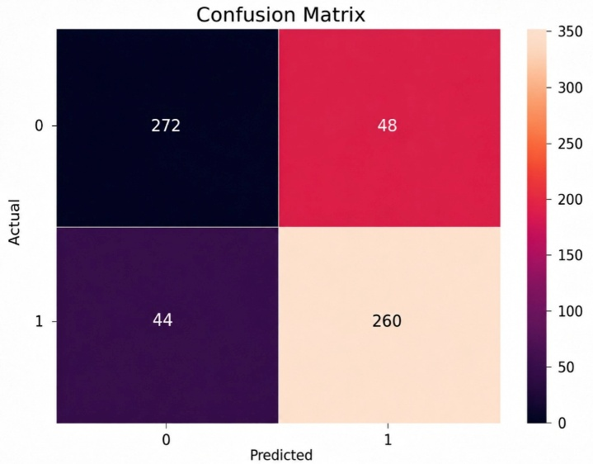
Fig. 2 Performance Analysis of MobileNetV2 Based on
Confusion Matrix

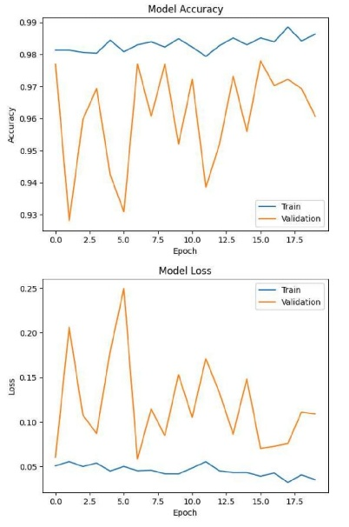
Fig. 3 Performance Evaluation of MobileNetV2 Based on
Accuracy and Loss Curves

B. ResNet50 Results
ResNet50 achieved an accuracy of 90.06% outperforming MobileNetV2 and exhibiting superior results in pneumonia diagnosis [6]. Confusion matrix is illustrated in Figure 4, with 276 True Negative and 286 True Positive cases, in addition to 28 False Positive and 34 False Negative cases. This suggests that the model demonstrated excellent results in diagnosing pneumonia. Figure 5 represents the accuracy and loss plots, which illustrate that the training and validation accuracy are high with a small amount of fluctuation. Moreover, the loss tends to decrease epoch by epoch, signifying that the learning process is successful despite some variation in validation loss [5]. Overall, ResNet50 outperformed MobileNetV2 because of its ability to learn deep features.

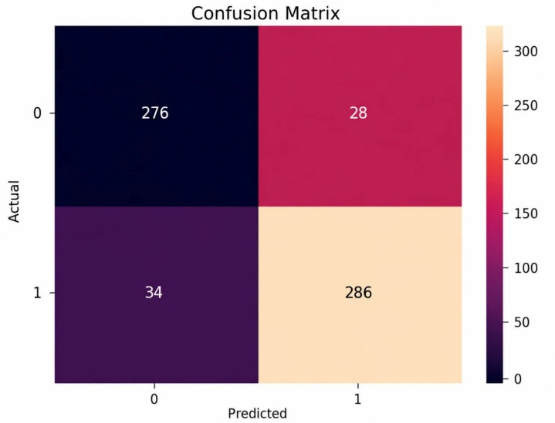
Fig. 4 Confusion Matrix for Pneumonia Classification
Using ResNet50

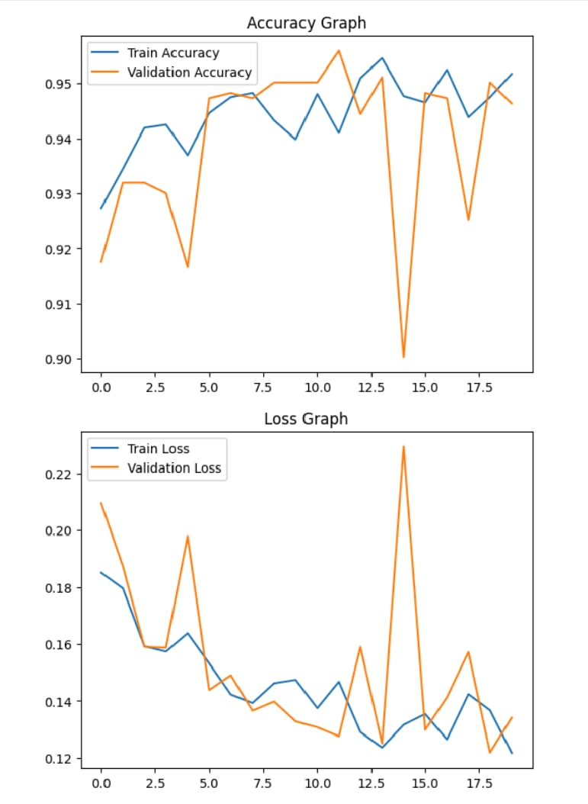
Fig. 5 Accuracy and Loss Curves of ResNet50
model

C. Effectiveness of Hybrid Model
The hybrid model using MobileNetV2 and ResNet50 archived an accuracy of 94.55% in pneumonia detection, which is better than either models used independently [2]. Figure 6 represents the confusion matrix. The number of normal cases accurately identified by the hybrid model is 221, and the number of pneumonia cases predicted with precision is 369. A class of 13 normal cases were mismatched as pneumonia, and 21 pneumonia cases were misclassified as normal. This is an improvement in the prediction capacity. Figure 7 presents the graphs for accuracy and loss. Compared with the individual models, the hybrid model shows better accuracy and loss curves.

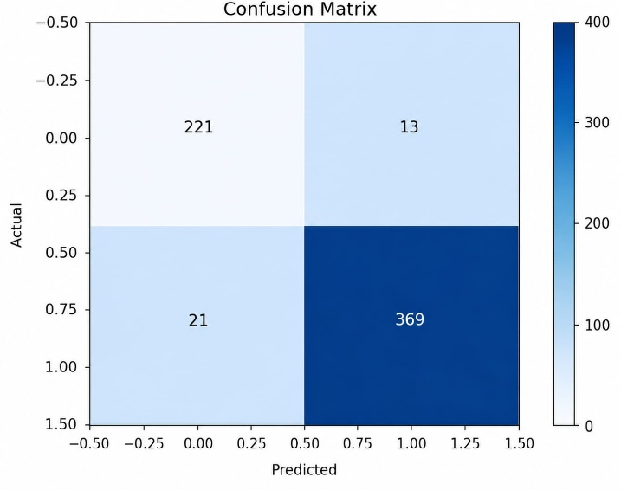
Fig. 6 Confusion Matrix for Hybrid Model

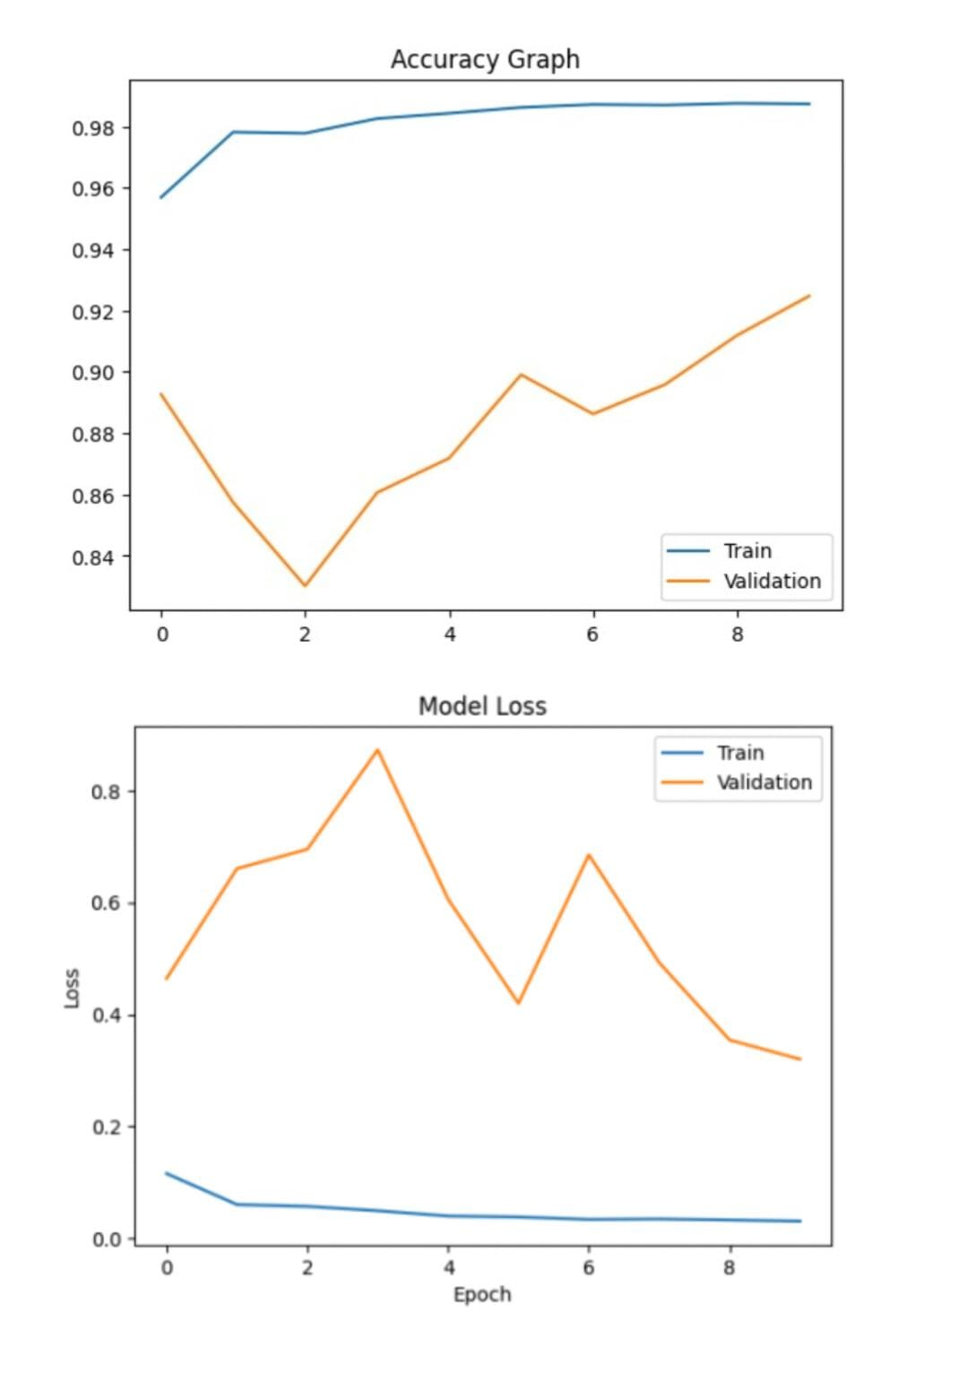
Fig. 7 Analysis of Accuracy and Loss Trends in Hybrid model combining MobileNetV2 and ResNet50

V. Comparative Analysis

S. No | Proposed Model | Accuracy (%)
1.) | MobileNetV2 | 85.25%
2.) | ResNet50 | 90.06%
3.) | Hybrid Model (MobileNetV2+ResNet50) | 94.55%
Table.1 Classification Accuracy of Proposed Models

Accuracy of MobileNetV2, ResNet50, and the proposed hybrid model is compared in the given table:
The MobileNetV2 model gave an accuracy result of 85.25%. Although this is a good result, the model uses less computational power and may not be able to learn deeper features effectively [3]. However, the ResNet50 model performed better with a high accuracy level of 90.06% as it has residual connections and thus can learn deeper features [6]. The proposed hybrid model, which incorporates both models, archived a higher accuracy of 94.55%, surpassing the performance of both individual models. This higher level of accuracy results from the combination of efficient feature extraction and deep feature learning [2]. Therefore, it is evident that the hybrid model performs better than either of the models on its own.

VI. Conclusion
An AI system to detect pneumonia by utilizing hybrid deep learning architecture including MobileNetV2 and ResNet50 has been suggested in this paper. The goal of the work is to improve classification by utilizing two different deep learning architectures in combination. According to the findings, the accuracies for MobileNetV2 and ResNet50 were 85.25% and 90.06%, respectively, while the accuracy obtained from the suggested hybrid model is 94.55%. It can be observed that the hybrid model can effectively help improve the efficiency of feature extraction and reduce the probability of errors. The results indicate that the proposed model archived good training performance, with stable accuracy occurs epochs and a low loss rate. In addition, the utilization of preprocessing techniques helped enhance the generalization ability of the model. Hence, the proposed system can be used as an effective decision support system for healthcare professionals to detect pneumonia in a timely manner.

References
1.) Jaiswal, A. K., Tiwari, P., Kumar, S., Gupta, D., Khanna, A., & Rodrigues, J. J. (2019). Identifying pneumonia in chest X-rays: A deep learning approach. Measurement, 145, 511-518.
2.) Masad, I. S., Alqudah, A., Alqudah, A. M., & Almashaqbeh, S. (2021). A hybrid deep learning approach towards building an intelligent system for pneumonia detection in chest X-ray images. Int. J. Electr. Comput. Eng, 11(6), 5530-5540.
3.) Fırat, H., & Üzen, H. (2024). Detection of Pneumonia using a hybrid approach consisting of MobileNetV2 and squeeze-and-excitation network. Türk Doğa ve Fen Dergisi, 13(1), 54-61.
4.) Gu, X., Pan, L., Liang, H., & Yang, R. (2018, March). Classification of bacterial and viral childhood pneumonia using deep learning in chest radiography. In Proceedings of the 3rd international conference on multimedia and image processing (pp. 88-93).
5.) Yaseliani, M., Hamadani, A. Z., Maghsoodi, A. I., & Mosavi, A. (2022). Pneumonia detection proposing a hybrid deep convolutional neural network based on two parallel visual geometry group architectures and machine learning classifiers. IEEE access, 10, 62110-62128.
6.) Çınar, A., Yıldırım, M., & Eroğlu, Y. (2021). Classification of pneumonia cell images using improved ResNet50 model. Traitement du Signal, 38(1), 165-173.
7.) El Asnaoui, K., Chawki, Y., & Idri, A. (2021). Automated methods for detection and classification pneumonia based on x-ray images using deep learning. In Artificial intelligence and blockchain for future cybersecurity applications (pp. 257-284). Cham: Springer International Publishing.
8.) Yu, Y., Tang, T., Tian, Z., Li, P., & Su, J. (2025, October). CheX-PD: Chest X-rays Diagnosis Using Selfsupervised learning for General Pneumonia Detection. In Proceedings of the 2025 18th International Conference on Computer Science and Information Technology (pp. 196-203).
9.) Chest X-Ray Images (Pneumonia), Kaggle Dataset
https://www.kaggle.com/datasets/paultimothymooney/chest-xray-pneumonia⁠
10.) Jain, R., Nagrath, P., Kataria, G., Kaushik, V. S., & Hemanth, D. J. (2020). Pneumonia detection in chest X-ray images using convolutional neural networks and transfer learning. Measurement, 165, 108046.
11.)Lim, W. S. (2021). Pneumonia—overview. Encyclopedia of respiratory medicine, 185.
12.) Lutfiyya, M. N., Henley, E., Chang, L. F., & Reyburn, S. W. (2006). Diagnosis and treatment of community-acquired pneumonia. American family physician, 73(3), 442-450.
13.) Swetha, K. R., Niranjanamurthy, M., Amulya, M. P., & Manu, Y. M. (2021, July). Prediction of pneumonia using big data, deep learning and machine learning techniques. In 2021 6th international conference on communication and electronics systems (ICCES) (pp. 1697-1700). IEEE.
14.) Elshennawy, N. M., & Ibrahim, D. M. (2020). Deep-pneumonia framework using deep learning models based on chest X-ray images. Diagnostics, 10(9), 649.
15.) Stokes, K., Castaldo, R., Federici, C., Pagliara, S., Maccaro, A., Cappuccio, F., ... & Pecchia, L. (2022). The use of artificial intelligence systems in diagnosis of pneumonia via signs and symptoms: A systematic review. Biomedical Signal Processing and Control, 72, 103325.

